**FORECASTING METHODOLOGIES PATTERN OF ENERGY CONSUMPTION**

Balancing the production and consumption of electricity is an urgent task. Its implementation largely depends on the means and methods of planning electricity production. Forecasting is one of the planning tools since the availability of an accurate forecast is a mechanism for increasing the validity of management decisions. This study provides an overview of the methods used to predict electricity supply requirements to different objects. The methods have been reviewed analytically, taking into account the forecast classification according to the anticipation period. In this way, the methods used in operative, short-term, medium-term, and long-term forecasting have been considered. Both classical and modern forecasting methods have been identified when forecasting electric energy consumption. Classical forecasting methods are based on the theory of regression and statistical analysis (regression, autoregressive models); probabilistic forecasting methods and modern forecasting methods use classical and deep-machine-learning algorithms, rank analysis methodology, fuzzy set theory, singular spectral analysis, wavelet transformations, Gray models, etc. Due to the need to take into account the specifics of each subject area characterizing an energy facility to obtain reliable forecast results, power consumption modeling remains an urgent task despite a wide variety of other methods. The review was conducted with an assessment of the methods according to the following criteria: labor intensity, requirements for the initial data set, scope of application, accuracy of the forecasting method, the possibility of application for other forecasting horizons. The above classification of methods according to the anticipation period allows highlights the fact that when predicting power consumption for different time intervals, the same methods are often used. Therefore, it is worth emphasizing the importance of classifying the forecast over the forecasting horizon not to differentiate the methods used to predict electricity consumption for each period but to consider the specifics of each type of forecasting (operative, short-term, medium-term, long-term).

Introduction

The dynamics of the growth of electricity consumption have been maintained in the world for more than 30 years (Figure 1). There are no prerequisites for reducing electricity consumption in the future, since at the present stage of human development, electricity is a key resource—professional and household human activity are impossible without the use of electricity. According to statistics on the world energy and climate portal Enerdata for 2021, electricity consumption in that year amounted to 24,877 TWh, which is 5.5% and 4.8% more than in 2020 and 2019, respectively. The growth of electricity consumption is also confirmed by statistics in the field of global electrification of final consumption. The trend towards an increase in electrification in the world continues to be traced: in 2021, the indicator reached 20.4% (+1 point compared to 2019).

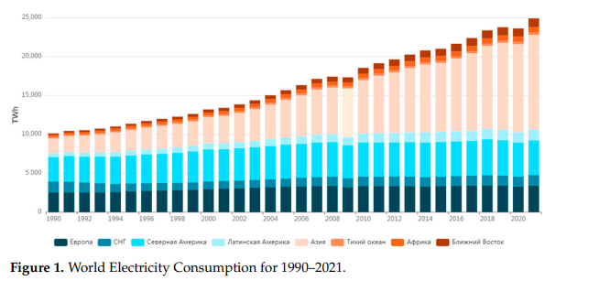

According to Enerdata’s global energy and climate data, in 2021, Russia was among the top five countries in terms of electricity consumption. The highest electricity consumption was in China (7714 TWh), followed by the USA (3869 TWh), India (1355 TWh), Russia (963 TWh TWh), and Japan (916 TWh). According to the electricity consumption schedule for the period from 1990 to 2021, shown in Figure 1, there is a noticeable trend in the growth of electricity consumption in the world. In Russia, from 2017 to 2021, electricity consumption increased by 58 TWh. The following dynamics of electricity consumption can be observed in a number of countries. For instance, in China, the consumption increased by 1834 TWh; in the USA, it decreased by 18 TWh; in India, there was an increase of 206 TWh; in Japan, consumption reduced by 64 TWh. The share of using electricity as an energy source is growing, and in 2021, it made up 10% of the world consumption of all types of energy sources (29% oil, 24% natural gas, 27% coal, 10% biomass). The dynamic pattern of electricity consumption in the five countries with the highest electricity demand from 2000 to 2021 is shown in the Figure 2

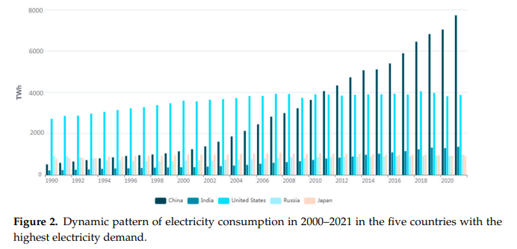

In this regard, energy saving issues are extremely important to maintaining the uninterrupted operation of electric power systems and providing consumers with electricity of proper quality. Energy saving refers to a set of measures for the rational use of energy resources, increasing the share of renewable energy sources in total electricity production, and other measures aimed at reducing the use of energy resources and contributing to solving environmental problems. Without the availability of energy-saving measures, it is not possible to manage the growing demand for electricity every year. To ensure the uninterrupted operation of electric power systems (EES), it is necessary to maintain a balance of power and consumption in the EES. This implies the need to ensure the proper level of frequency and voltage in the EES. With sudden changes (increase or decrease) in electricity consumption, there is a violation of the balance of power and electricity consumption, which leads to failures and accidents in power plants. In addition, it is impossible to operate the wholesale electricity and capacity market without managing power consumption modes. Therefore, the management of operating modes in the EES is a complex task, and for its effective solution, detailed planning of electricity consumption is necessary. One of the possible solutions to the problem of load planning of electric power systems is the forecasting of electricity consumption. The presence of a reliable forecast of electricity consumption contributes to the validity of decision making when managing the operating modes of power facilities.

Managing the process of electrical energy consumption is efficient due to the functioning of various incentive mechanisms that operate on the wholesale electricity and power market (WECM). This operates on the mechanism of economic management of consumer demand, known as the “Demand response”, or DR. This mechanism includes a set of measures to reduce electrical energy consumption, including during peak hours, thereby contributing to a uniform and more efficient use of the capacities of generation facilities. DR can be referred to as the technology of price-dependent consumption, which implies the influence of consumers on the demand and electricity price in different periods of time (days). Therefore, for example, during peak hours on the WECM, consumers are offered lower-price electricity in return for reducing electricity consumption. The WECM uses such tools as a balancing market, a day-ahead market, bilateral agreements, competitive power take-off procedures, etc. The conditions created on the WECM encourage consumers to switch to economically advantageous conditions, assuming the existence of an accurate plan for electricity consumption. Therefore, forecasting is an urgent and important task whose solution will allow WECM participants (electricity buyers) to receive the opportunity to purchase electricity at favourable rates. The forecasting of electricity consumption by WECM participants in particular and the WECM’s functioning as a whole contribute to the balance between supply and demand for the WECM and, as a result, improve the efficiency of managing the process of electricity production and consumption.

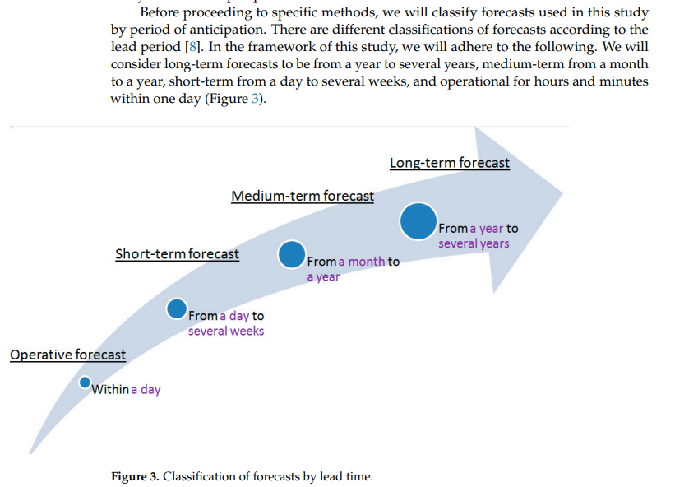

Differentiation of methods by forecast lead time allowed us to investigate in more detail the methods most effectively used for forecasting for the corresponding lead time. This separation of methods, in our opinion, allows us to better navigate the thematic literature and also allows us to identify the key features of the application conditions for each forecasting period. Figure 3. Classification of forecasts by lead time. Differentiation of methods by forecast lead time allowed us to investigate in more detail the methods most effectively used for forecasting for the corresponding lead time. This separation of methods, in our opinion, allows us to better navigate the thematic literature and also allows us to identify the key features of the application conditions for each forecasting period. It is also worth noting the problems encountered by the authors during this review. Firstly, it is worth noting the main drawback of most empirical studies, which consists of the difficulty of reproducing research results due to the difference in the conditions of their conduct, the unavailability of data, the insufficient level of detail of the solution, and other reasons that make it difficult to objectively evaluate each work. Therefore, the authors recommend that researchers, when choosing a forecasting method, pay attention not only to quantitative estimates of the results of using a particular method but also to the qualitative features of each method, the specifics of each subject area, and the assessment of the applicability of the method in specific conditions. This review presents the results of comparing the most popular and promising forecasting methods, analysis of the conditions of their application, and quantitative indicators of the applicability of these methods. The authors attempted to provide an objective qualitative and quantitative assessment of classical and modern approaches.

**Comparative Analysis of Forecasting Methods**

Forecasting electricity consumption is an effective tool in the process of making managerial decisions when planning electricity costs. An analysis of scientific research has been shown that firstly, there are no universal methods for predicting electricity consumption and that secondly, the constant increase in the requirements for forecast accuracy requires the development of new approaches. Therefore, it was decided that we would review the methodological basis for forecasting electricity consumption. A feature of this work is a comprehensive analysis of existing methods for predicting power consumption and an assessment of the prospects and risks of their application. Now, we will more closely review the goals of each type of forecasting. Short-term and operational forecasting is necessary for effective management of the electricity demand, its accumulation possibility. Having an accurate forecast for a day or several days ahead helps to reduce peak loads. The analysis of literary sources confirms the idea that operational and short-term forecasting is relevant for planning electricity demand both for regional energy systems (regional dispatch offices, megacities, etc.) and for so-called microgrids, which are individual large consumers of electricity: buildings (office, educational, administrative, households, hotels, etc.), various infrastructure facilities (treatment facilities, etc.), industrial enterprises, etc. Medium-term forecasting of electricity consumption is necessary for planning the production and maintenance of the electrical network. Monthly forecasting plays a particularly important role in the operation of thermal power plants, which are among the most important bases for dispatching coal and electricity trade .Long-term forecasting is used in elaborating the strategies for the development of energy systems at the state level, separately within a particular field (industry, etc.), and for planning capital construction or repair of major production and infrastructure facilities. To obtain electricity consumption forecast values, several different development scenarios are usually used (GDP volume, production growth rates, etc.). In addition, an accurate long-term forecast is necessary to develop effective environmental strategies (decarbonization of industry, etc.). Different methods are used depending on the forecasting horizon. The most popular method at present is the use of classical and deep-machine-learning algorithms, genetic algorithms, wavelet analysis, singular spectral analysis, etc. However, the choice of methods depends on the problem being solved and the structure of the initial data, and—as many researchers note—classical methods used in forecasting electricity consumption often make it possible to obtain a forecast whose accuracy is comparable to that obtained as a result of forecasting by more complex and computationally intensive intellectual methods.

**Operative Forecasting**

Operational forecasting is the research subject of many scientists; it touches upon the issues of operational management of the operating modes of power facilities. The day-ahead market provides for hourly differentiation of the electricity tariff within a day, so intraday forecasting is especially important when the WECM operates

**Short-Term Forecasting**

Short-term forecasting of electricity consumption is the most popular type based on the constantly growing number of publications. The relevance of short-term forecasting is due to the need to have an accurate forecast of electricity consumption for a day or several days to productively anticipate most WECM procedures. The increasingly complex requirements of the WECM for the forecast quality (for a day ahead, for several days or weeks) and the emergence of new data mining algorithms (new neural network optimization algorithms, new neural network architectures, hybrid models, etc.) contribute to the growth of ongoing research in this area. In addition, the results of short-term forecasting are required for making managerial decisions when planning the operation modes of the electric power system.

**Medium-Term Forecasting**

Medium-term forecasting of electricity consumption is necessary to substantiate the technical and economic performance of the energy company and its tariff policy, to draw up repair schedules for the main equipment, and for the process of making managerial decisions when planning electricity costs and developing strategies to minimize them. The aforementioned monograph [26] proposes two models similar to those developed for daily forecasting. This is a model based on ANN and FNN. The configuration of the model is described in detail in Ref. [26]. The ANN model contains one hidden layer with three neurons. The following data are fed to the model inputs: power consumption for the previous month, minimum and maximum monthly loads, average monthly temperature, day length, the number of holidays in the month preceding the forecast, the number of holidays, and forecast values of temperature and longitude for the forecast month.

**Long-Term Forecasting**

Long-term forecasting is necessary to developing most strategies. Data on planned industrial production directly affect the GDP level and a number of macroeconomic and microeconomic indicators. In addition, an accurate forecast involving different scenarios of input parameters (for example, production volume) affects the development level of the country as a whole. Long-term forecasting is also relevant when making managerial decisions at industrial enterprises and other facilities, as it allows the modelling of an object’s change in the long term according to various scenarios and the making of informed management decisions when developing strategies for its (enterprise or other object) progress. Long-term forecasting, like other forecasting types, plays an important role when implementing economically profitable strategies but can also contribute to solving environmental problems or developing recommendations for their solution. For example, when forecasting electricity consumption, it is necessary to take into account the industry decarbonization strategy and other factors that affect the consumption and production of electricity in the long term.